There are multiple ways of creating an object. The object literal syntax is the easiest one.

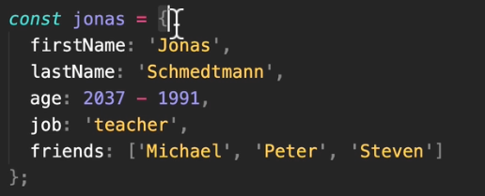

There are two ways of getting data from an object. The dot and the bracket notation.

Dot notation is the traditional oop language type and the bracket notation is like the array, but instead of the index we write the property name.



The bracket notation is better cause in some cases we might need dynamic parameter name. for example,

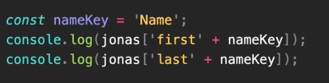

But if we try to use dynamic property with dot notation it will throw errors.

It is advised to use the bracket notations.